2022 Clovis Rotational Freshman Boys Basketball Tournament
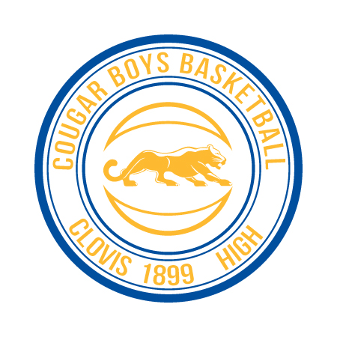
Blue Bracket Gold Bracket
Clovis High Atwater
Buchanan Clovis North
Caruthers Clovis West
Central Edison
Clovis East
Sanger

*All games played in the South Gym
*Team listed first is the home team and will wear light colored jerseys
Wednesday 12/14 Thursday 12/15
2:30pm: Buchanan vs Central 2:30pm: Clovis West vs Edison
3:45pm: Caruthers vs Clovis East 3:45pm: Clovis North vs Atwater
5:00pm: Clovis West vs Atwater 5:00pm: Caruthers vs Sanger
6:15pm: Clovis High vs Sanger 6:15pm: Clovis East vs Buchanan
7:30pm: Edison vs Clovis North 7:30pm: Clovis High vs Central
Friday 12/16 Saturday 12/17
2:30pm: Central vs Clovis East 1:45pm: (South Gym)
3:45pm: Atwater vs Edison 2:00pm: 4th Place Blue vs 4th Place Gold
5:00pm: Sanger vs Buchanan 3:15pm: 3rd Place Blue vs 3rd Place Gold
6:15pm: Clovis North vs Clovis West 4:30pm: 2nd Place Blue vs 2nd Place Gold
7:30pm: Clovis High vs Clovis High 2 (JV) 5:45pm: 1st Place Blue vs 1st Place Gold

